Chapter One : Computer Network

Introduction to Computer Networking

Compiled
By
Er. Jeet Narayan Yadav

Basics of Data Communication and Computer Networking :: 33

BASICS OF DATA COMMUNICATION
AND
COMPUTER NETWORKING

INTRODUCTION

- Computers are used to generate information. Generated information is not useful in itself. The information must be delivered to the right person at the right time. Often information must be transmitted from one location to another. This process is called data communication.

- Office automation is based on communication; the transfer of information. Advances in communication technology, combined with rapidly evolving computer technology, have made possible much of the progress in the field.
- Electronic communication consists of telecommunication and data communications. Telecommunication refers to the use of telephone, telegraph, and radio or television facility to transmit information, either directly or via computer. Data communication means the transfer of data or information between computers devices.

DATA COMMUNICATION

- Data communication is the active process of transporting data from one point to another.
- Networks are communication system designed to convey information from a point of origin to a point of destination. Note that they are communication system, not computer system.
- The operative word is communication, the transfer of information from one device to another.

- Networks come in two flavors – local as in local area network, which cover a small area and have a finite, relatively small, number of users and global or long-haul, which cover long distance and have an unlimited number of users.
- Telephone networks are long network. It refers to the transmission of the digital signals over a communication channel between the transmitter and receiver computers. Communication is possible only with wired and wireless connectivity of the computers with each other.

The effectiveness of a data communication system depends on three fundamental characteristics:

1. Delivery: The system must deliver data to the correct destination. Data must be received by the intended device or user and only by that device or user.

2. Accuracy: The system must deliver data accurately. Data that have been altered in transmission and left uncorrected are unusable.

3. Timeliness: The system must deliver data in a timely manner. Data delivered late are useless. In the case of video, audio and voice data, timely delivery means delivering data as they are produced, in the same order that they are produced, and without significant delay. This kind of delivery is called real-time transmission.

Data Communication Component

The following are the basic components for working of a communication system. (see fig. 2.1)
1. Transmitter

2. Receiver

3. Medium

4. Message

5. Protocol

- The transmitter sends the message and the receiver receives the message.
- The medium is the channel over which the message is sent
- The protocol is the set of rules that guides how the data is transmitted from encoding to decoding.
- The message of course is central to all the components. The message is the data that is being communicated.

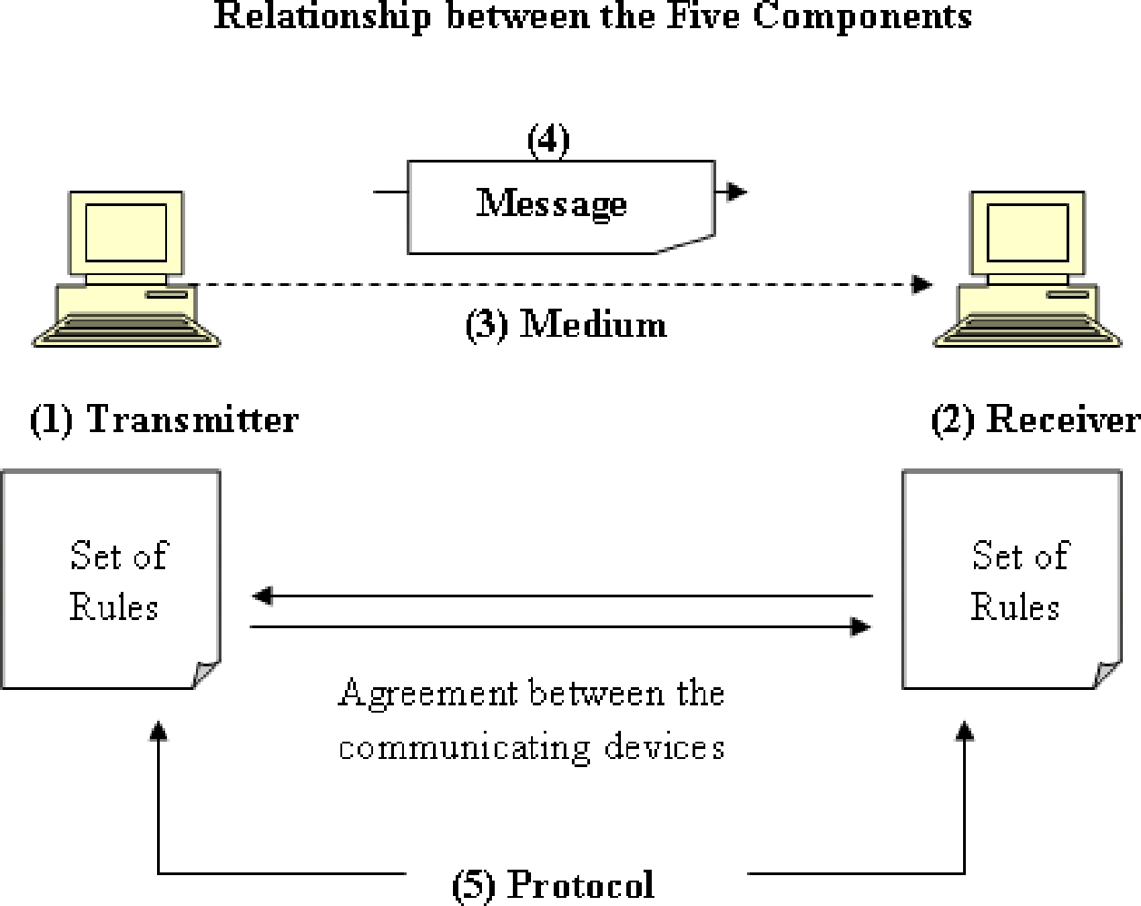

Fig 2.1 : Data Communication Components

Transmitter: The transmitter is the device that sends the message. It can be a computer, workstation, telephone handset, video camera, and so on.

Receiver: The receiver is the device that receives the message. It can be a computer, workstation, telephone handset, television, and so on.

Medium: The transmission medium is the physical path by which a message travels from sender to receiver. It can consist of twisted pair wire, coaxial cable, fiber-optic cable, laser or radio waves (terrestrial or satellite microwave).

Message: The message is the transmission (data) to be communicated. It can consist of text, number, pictures, sound, or video or any combination of these.

Protocol: A protocol is a set of rules that governs data communication. It represents an agreement between the communicating devices. Without a protocol, two devices may be connected but not communicating, just as a person speaking German cannot be understood by a person who speaks only Japanese.

Basic of Networking
• A computer network consists of two or more computers that are linked in order to share resources such as printers and CD-ROMs, exchange files, or allow electronic
Communications. The computers on a computer network may be linked through cables, telephone lines, radio waves, satellites, or infrared light beams.
• The below diagrams illustrates a kind of network.

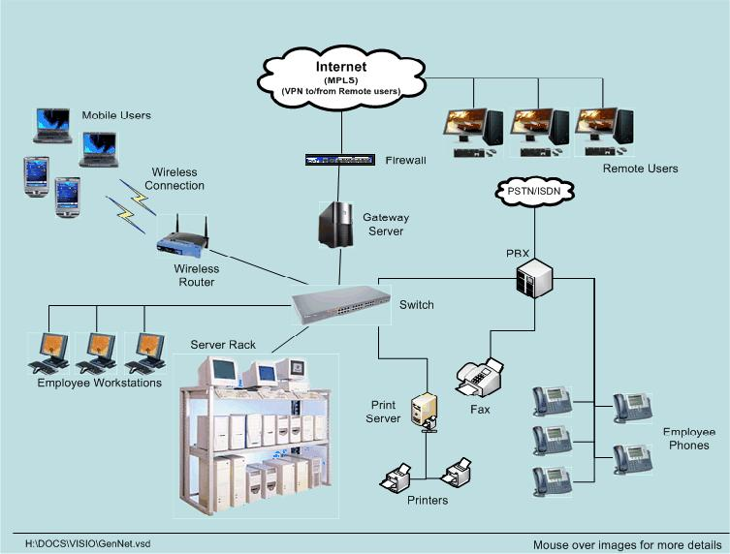
Types of Networks

Computer Networks fall into three classes regarding the size, distance and the structure namely:

1. LAN (Local Area Network),

2. MAN (Metropolitan Area Network),

3. WAN (Wide Area Network).

• A LAN links a small group of functionally similar workstations within a local geographic area such as a series of adjacent cubicles or offices on the same floor.

• Once the Computer network expands to include other floors or divers office within a metropolitan area, it becomes a MAN. Finally, a WAN is simply a LAN of LANs. WANs expand the boundaries of computer networking to a global or even galactic scale.

1. LAN (Local Area Network)

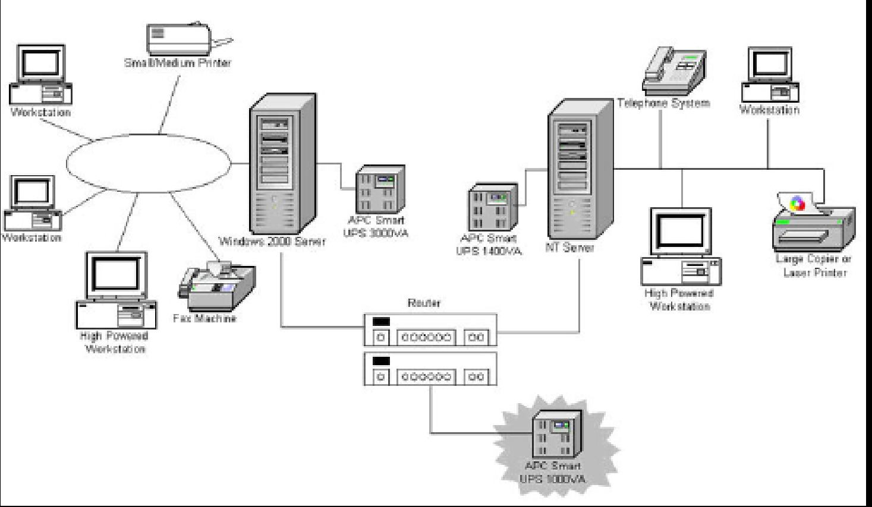

• A Local Area Network is a computer network covering a small Networks geographical area, like a home, office, or groups of buildings e.g. a school Network. For example, a library will have a wired or wireless LAN Network for users to interconnect local networking devices e.g., printers and servers to connect to the internet.

• The defining characteristics of LANs Network, in contrast to Wide Area Networks (WANs), includes their much higher data-transfer rates, smaller geographic range, and lack of need for leased telecommunication lines.

• LAN technologies operate at speeds up to 10 Gbit/s. Smaller Networks generally consist of a one or more switches linked to each other - often with one connected to a router, cable modem, or DSL modem for Internet access. LANs Network may have connections with other LANs Network via leased lines, leased services.

2. MAN (Metropolitan Area Networks)

• MAN stands for Metropolitan Area Networks is one of a number of types of networks. A MAN (Metropolitan Area Networks) is a relatively new class of network. MAN is larger than a local area network (LAN) and as its name implies, covers the area of a single city. MANs (Metropolitan Area Networks) rarely extend beyond 100 KM and frequently comprise a combination of different hardware and transmission media.

• A MAN (Metropolitan Area Networks) usually interconnects a number of local area networks (LANs) using a high-capacity backbone technology, such as fiber-optical links, and provides up-link services to wide area networks (or WAN) and the Internet.

• MAN adopted technologies from both LAN and WAN to serve its purpose. MAN links between LANs have been built on fibre optical cables or using wireless technologies such as microwave or radio.

3. WAN (Wide Area Networks)

• A wide area network (WAN) is a telecommunication network. A wide area network is simply a LAN of LANs or Network Of Networks. WANs connect LANs that may be on opposite sides of a building, across the country or around the world. WANs
are characterized by the slowest data communication rates and the largest distances.

• Computers connected to a Wide Area Networks are often connected through public networks, such as the telephone system. They can also be connected through leased lines or satellites. The largest WAN (wide area networks) in existence is the Internet. Some segments of the Internet, like VPN (Virtual Private Networks) based extranets, are also WANs (wide area networks) in themselves. Finally, many WANs (wide area networks) are corporate or research networks that utilize leased lines.

• WANs (wide area networks) generally utilize different and much more expensive networking equipment than do LANs (Local Area Networks).

• We can present the LAN,MAN and WAN network with following geographical boundaries having unseen network equipments as below.

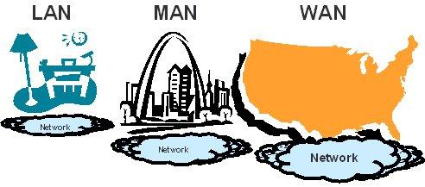

Broadly speaking, there are two types of network configuration,
1. peer-to-peer networks and
2. client/server networks.

1 . Peer-to-peer networks
• T h e s e n e t w o r k s are more commonly implemented where less than ten computers are involved and where strict security is not necessary. All computers have the same status, hence the term 'peer', and they communicate with each other on an equal
footing.
• Files, such as word processing or spreadsheet documents, can be shared across the network and all the computers on the network can share devices, such as printers or scanners, which are connected to any one computer.

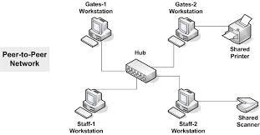

Fig 2: Peer to Peer Networking

2. Client/server networks
• These networks are also called Server Based or C-S Networks; are more suitable for larger networks. A central computer, or 'server', acts as the storage location for files and
applications shared o n t h e n e t w o r k . Usually t h e s e r v e r i s a h i g h e r t h a n a v e r a g e performance computer.

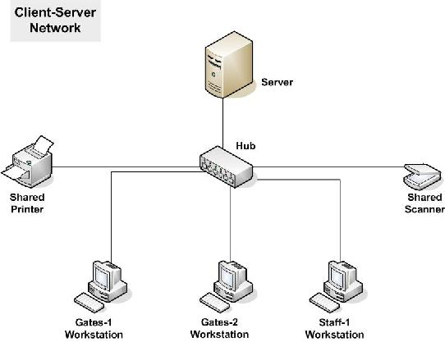

Fig 3: Client - Server Networking

• The server also controls the network access of the other computers which are referred to as the 'client' computers. Typically, teachers and students in a school will use the client computers for their work and only the network administrator (usually a designated staff member) will have access rights to the server.

Table 1 provides a summary comparison between Peer-to-Peer and Client/Server Networks.

Peer-to-Peer Networks vs Client/Server Networks
Peer-to-Peer Networks | Client/Server Networks
• Easy to set up | • More difficult to set up
• Less expensive to install | • More expensive to install
• Can be implemented on a wide range of operating systems | • A variety of operating systems can be supported on the client computers, but the server needs to run an  operating system that supports  networking
• More time consuming to maintain the software being used | • Less time consuming to maintain the software being used (as most of
(as computers must be managed individually) | the maintenance is managed from the server)
• Very low levels of security supported or none at all. These can be very cumbersome to set up, depending on the operating system being used | • High levels of security are supported,  all of which are controlled from the server. Such measures prevent the deletion of essential system files or the changing of settings

Peer-to-Peer Networks vs Client/Server Networks
Peer-to-Peer Networks | Client/Server Networks
• Ideal for networks with less than 10 computers | • No limit to the number of computers that can be supported by the network
• Does not require a server | • Requires a server running a server operating system
• Demands a moderate level of skill to administer the network | • Demands that the network administrator  has a high level of IT skills with a good working knowledge of a server operating system
Table 1: Peer-to-Peer Networks vs Client/Server Networks

Network Categories

There are three types of enterprise network infrastructures, namely

1. Internet,

2. Intranet, and

3. Extranet.

Depending on the needs of an organization, a network may span a geographical divide or allow for interconnection between persons and devices within the same building. In this day and age, this interconnectivity is a matter of great importance because it facilitates the efficient running of an organization or helps it to maintain a competitive edge.

1. Internet

• The Internet is a global system of interconnected computer networks. It is not controlled by a central entity and therefore relies on network devices and accepted conventions and protocols to relay the data traffic until it gets to its destinations.

• Some countries have imposed rules to censor or otherwise control what kind of content is accessible by its citizen (i.e. China). However, except for the management of Internet Protocol addresses and the Domain Name System by ICANN (the Internet Corporation for Assigned Names and Numbers), the Internet remains unregulated and uncensored.

• The beginnings of the Internet can be traced back to the 1960s when the United States funded research by its military agencies to develop a fault-tolerant and robust distributed network of computers.

• The Internet is now global and in theory can be accessed by anyone who can get access from an Internet service provider.

2. Intranet

• On the other hand, an intranet is a private network that is setup and controlled by an organization to encourage interaction among its members, to improve efficiency and to share information, among other things.

• Information and resources that are shared on an intranet might include: organizational policies and procedures, announcements, information about new products, and confidential data of strategic value.

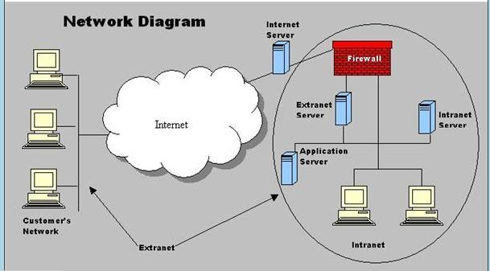

• An intranet is a restricted-access network that works much like the Internet, but is isolated from it. As is the case with the Internet, an intranet is based on TCP/IP protocols. Therefore, a web page in an intranet may look and act just like any other webpage on the Internet, but access is restricted to authorized persons and devices.

• In some cases, access to an intranet is restricted by not connecting it to other networks, but in other cases a firewall is used to deny access to unauthorized entities.

Note:

1. The difference between an intranet and the Internet is defined in terms of accessibility, size and control. Unless content filters are being used or the government is censoring content, the entire Internet’s content is accessible to everyone.

2. On the other hand an intranet is owned and controlled by a single organization that decides which members are allowed access to certain parts of the intranet. In general, an intranet is usually very small and is restricted to the premises of a single organization.

3. Extranet

• An extranet is an extended intranet. In addition to allowing access to members of an organization, an extranet uses firewalls, access profiles, and privacy protocols to allow access to users from outside the organization.

• In essence, an extranet is a private network that uses Internet protocols and public networks to securely share resources with customers, suppliers, vendors, partners or other businesses.

• Both intranets and extranets are owned, operated and controlled by one organization.
However, the difference between intranets and extranets is defined in terms of who has access to the private network and the geographical reach of that network. Intranets allow only members of the organization to access the network, while an extranet allows persons from outside the organization (i.e. business partners and customers) to access the network.

• Usually, network access is managed through the administration of usernames and passwords, which are also used to determine which parts of the extranet a particular user can access.

Summary

1. The Internet, extranets, and intranets all rely on the same TCP/IP technologies. However, they are different in terms of the levels of access they allow to various users inside and outside the organization and the size of the network.

2. An intranet allows for restricted access to only members of an organization; an extranet expands that access by allowing non-members such as suppliers and customers to use company resources.

3. The difference between the Internet and extranets is that while the extranet allows limited access to non-members of an organization, the Internet generally allows everyone to access all network resources.

Wireless Networks
• The term 'wireless network' refers to two or more computers communicating using standard network rules or protocols, but without the use of cabling to connect the comput e rs together. Instead, the computers use wireless radio signals to send information from one to the other.

• A wireless local area network (WLAN) consists of two key components: an access point (also called a base station) and a wireless card. Information can be transmitted between these two components as long as they are fairly close together (up to 100 metres indoors or 350 metres outdoors).

Fig 7a: Wireless Access point (A.P.) or Wireless Base station
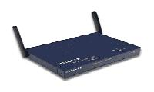

WLAN has some specific advantages:
➢ It is easier to add or move workstations.
➢ It is easier to provide connectivity in areas where it is difficult to lay cable.
➢ Installation can be fast and easy and can eliminate the need to pull cable through walls and ceilings.
➢ Access to the network can be from anywhere in the school within range of an access point
➢ Portable or semi-permanent buildings can be connected using a wireless LAN
➢ Where laptops are used, the ‘computer suite’ can be moved from classroom to classroom on mobile carts.
➢ While the initial investment required for wireless LAN hardware can be similar to the cost of wired LAN hardware, installation expenses can be significantly lower.
➢ Where a school is located on more than one site (such as on two sides of a road), it is
possible with directional antennae, to avoid digging trenches under roads to connect the sites.
➢ In historic buildings where traditional cabling would compromise the façade, a wireless

LAN can avoid drilling holes in walls.
➢ Long-term cost benefits can be found in dynamic environments requiring frequent moves and changes
➢ They allow the possibility of individual pupil allocation of wireless devices that move around the school with the pupil.
WLANs also have some disadvantages:

➢ As the number of computers using the network increases, the data transfer rate to each computer will decrease accordingly
➢ As standards change, it may be necessary to replace wireless cards and/or access points
➢ Lower wireless bandwidth means some applications such as video streaming will be more effective on a wired LAN
➢ Security is more difficult to guarantee, and requires configuration
➢ Devices will only operate at a limited distance from an access point, with the distance determined by the standard used and buildings and other obstacles between the access point and the user
➢ A wired LAN is most likely to be required to provide a backbone to the wireless LAN; a
wireless LAN should be a supplement to a wired LAN and not a complete solution
➢ Long-term cost benefits are harder to achieve in static environments that require few moves and changes
➢ It is easier to make a wired network ‘future proof’ for high data transfer.

Advantages of Networking

1. Speed.

Networks provide a very rapid method for sharing and Transferring files. Without a network, files are shared by copying them to floppy disks, then carrying or sending the disks from one computer to another. This method of transferring files in this manner is very time-consuming.

2. Cost.
The network version of most software programs are available at considerable savings when compared to buying individually licensed copies. Besides monetary savings, sharing a
program on a network allows for easier upgrading of t h e p r o g r a m . The changes have to be done only once, on the file server, instead of on all the individual workstations.

3. Centralized Software Management.
One of the greatest benefits of installing a network at a school is the fact that all of the software can be loaded on one computer (the file server). This eliminates that need to spend time and
energy installing updates and tracking files on independent computers throughout the building.

4. Resource Sharing.
Sharing resources is another area in which a network exceeds stand-alone computers.

Most s t u d e n t s c a n n o t a f f o r d e n o u g h l a s e r p r i n t e r s , fax m a c h i n e s , modems, scanners, and CD-ROM players for each computer. However, if these or similar peripherals are added to a network, they can be shared by many users.
5. Flexible Access.
School networks allow students to access their files from computers throughout the school. Students can begin an assignment in their classroom, save part of it on a public access area of the network, then go to the media center after school to finish their work. Students can also work cooperatively through the network.

6. Security.
Files and programs on a network can be designated as "copy inhibit," so that you do
not have to worry about illegal copying of programs. Also, passwords can be established for specific directories to restrict access to authorized users.

Disadvantages (Main challenges) of installing a Network

1. Costs
Although a network will generally save money over time, the initial costs can be
substantial, and the installation may require the services of a technician.

2. Requires Administrative Time.
Proper maintenance of a network requires considerable time and expertise. Many
students have installed a network, only to find that they did not budget for the necessary administrative support.

3. Computer Networks can Fail
Computer networks can be so powerful and useful that it is common for them to be used for more
and more purposes. A network might start out as a small convenience, but later may become mission-critical - the computer can no longer do its job without a properly functioning network. If the network was originally only a convenience, there may not be any attention given to what might happen if the network were to fail, even after the network becomes indispensable. All of the computers in an office building might become completely useless if a single network component fails.
4. Information Security
If a computer is connected to a network, it is much easier to send any secret information stored on
that computer to some other computer on the network.

5. Vulnerability to Remote Exploits

If a computer is on a network, not only can it send information to any other computer on the network; it is also able to receive messages from any other computer on the network. Because the people who write computer software are human and make mistakes, sometimes the software will have bugs in it that allow someone on a different computer on the network to send data to the

computer with the buggy software in such a way as to attack it - make it lock up or crash, make it slow down, or even take control of it.

6. Rapid Spread of Computer Viruses

Computer viruses are programs designed to take advantage of buggy software to spread copies of themselves. When computers are connected by a network, the virus can spread itself electronically, at computer speeds. Without a network, it can only spread as fast as the sneakernet can operate (as fast as people can carry disks between the computers).

7. Configuration Management

Sometimes (such as in medical equipment) it is important for a computer's software configuration to be predictable and stable. If a computer is connected to a network, it's easier to download and install software from the network onto the computer. This includes automatic software updates, so this can happen without any human intervention. If the new software hasn't been tested, it could cause unpredictable behavior and possibly endanger lives.

Explain Network Services

Network services are the thing that a network can do. The major networking services are

1. File Services: This includes file transfer, storage, data migration, file update, synchronization and achieving.
2. Printing Services: This service produces shared access to valuable printing devices.
3. Message Services: This service facilitates email, voice mails and coordinate object oriented applications.
4. Application Services: This services allows to centralize high profile applications to increase performance and scalability
5. Database Services: This involves coordination of distributed data and replication.

History and the evolution of the internet.

• The vast, global internet of today had rather humble origins when it initiated. In 1969, the Department of Defense Advanced Research Projects Agency (ARPA) developed an experimental network called ARPAnet to link together four supercomputing centres for military research. This network had the many and difficult design requirements that it had to be fast, reliable, and capable of withstanding a nuclear bomb destroying any one computer center on the network. From those original four

computers, this network evolved into the sprawling network of millions of computers we know today as the internet.

• The internet itself is really a massive "network of networks." There is no central "Internet, Inc," to which you can connect. Essentially, it is a collection of Internet service providers (ISPs) who each operate their own networks, with their own clients, and agree to interconnect with each other and exchange packets. Many of the large ISPs sell connections to their network to smaller ISPs, some of whom again sell connections to other ISPs.

• Ultimately, these ISPs at all levels sell connections to individuals and corporations, who then merge their networks (or individual computers) into this larger network called the internet.

• While there is no exact governance of the Internet, communication standards and coordination of ISP
actions are overseen by a nonprofit organization called the Internet Society.

• An affiliated organization, the Internet Engineering Task Force (IETF) coordinates the work of numerous committees that define Internet communication standards and research methods of explaining and improving Internet communication. The actual communication standards are referred to as RFCs (Requests for Comments) and are voluntarily adhered to by all ISPs.

• Internet users can be simply categorized as publishing and getting information on various subjects like marketing, management, science, new technologies, training materials, jobs, higher education, mathematics, music, games, software, etc. and E-Commerce

• And the kind of information available in the internet can also be listed as text documents, graphic files, sound and video files, downloadable games and software, demo games and software, etc.

• At the speed the internet has been evolving, many predictions can be made about the internet in the future, like main communication method coming with functions of being translated automatically into the language preferred by the receiver, finding a tune through humming into the microphone, virtual tours of a house, car, etc. could become common thing.

• This is what the Internet has become today, starting from its modest birth in 1969, to become an indispensable service for the human race at present and will remain the same in the future.

What is the Internet?

• The Internet is a worldwide system of interconnected computer networks that use the TCP/IP set of network protocols to reach billions of users. The Internet began as a U.S Department of Defense network to link scientists and university professors around the worold.

• A network of networks, today, the Internet serves as a global data communications system that links millions of private, public, academic and business networks via an international telecommunications backbone that consists of various electronic and optical networking technologies.

• Decentralized by design, no one owns the Internet and it has no central governing authority. As a creation of the Defense Department for sharing research data, this lack of centralization was intentional to make it less vulnerable to wartime or terrorist attacks.

• The terms Internet and World Wide Web are often used interchangeably; however, the internet and
World Wide Web are not one and the same.

• The Internet is a vast hardware and software infrastructure that enables computer interconnectivity. The Web, on the other hand, is a massive hypermedia database, a myriad collection of documents and other resources interconnected by hyperlinks. Imagine the World Wide Web as the platform which allows one to navigate the Internet with the use of a browser such as Internet Explorer or Mozilla Firefox.

• Follow the Internet Timeline below to see how the Internet has evolved over the years and take a glance at what lies ahead in the future as the Internet continues to change the world we live in.

Internet Timeline

❖ 1957 – USSR launches Sputnik into space. In response, the USA creates the Advanced Research Projects Agency (ARPA) with the mission of becoming the leading force in science and new technologies.

❖ 1962 – J.C.R. Licklider of MIT proposes the concept of a “Galactic Network.” For the first time ideas about a global network of computers are introduced. J.C.R. Licklider is later chosen to head ARPA's research efforts.

❖ 1962 - Paul Baran, a member of the RAND Corporation, determines a way for the Air Force to control bombers and missiles in case of a nuclear event. His results call for a decentralized network comprised of packet switches.

❖ 1968 - ARPA contracts out work to BBN. BBN is called upon to build the first switch.

❖ 1969 – ARPANET created - BBN creates the first switched network by linking four different nodes in California and Utah; one at the University of Utah, one at the University of California at Santa Barbara, one at Stanford and one at the University of California at Los Angeles.

❖ 1972 - Ray Tomlinson working for BBN creates the first program devoted to email.

❖ 1972 - ARPA officially changes its name to DARPA Defense Advanced Research Projects
Agency.

❖ 1972 - Network Control Protocol is introduced to allow computers running on the same network to communicate with each other.

❖ 1973 - Vinton Cerf working from Stanford and Bob Kahn from DARPA begin work developing
TCP/IP to allow computers on different networks to communicate with each other.

❖ 1974 - Kahn and Cerf refer to the system as the Internet for the first time.

❖ 1976 - Ethernet is developed by Dr. Robert M. Metcalfe.

❖ 1976 – SATNET, a satellite program is developed to link the United States and Europe. Satellites are owned by a consortium of nations, therby expanding the reach of the Internet beyond the USA.

❖ 1976 – Elizabeth II, Queen of the United Kingdom, sends out an email on 26 March from the
Royal Signals and Radar Establishment (RSRE) in Malvern.

❖ 1976 - AT& T Bell Labs develops UUCP and UNIX.

❖ 1979 - USENET, the first news group network is developed by Tom Truscott, Jim Ellis and Steve
Bellovin.

❖ 1979 - IBM introduces BITNET to work on emails and listserv systems.

❖ 1981 - The National Science Foundation releases CSNET 56 to allow computers to network without being connected to the government networks.

❖ 1983 - Internet Activities Board released.

❖ 1983 - TCP/IP becomes the standard for internet protocol.

❖ 1983 - Domain Name System introduced to allow domain names to automatically be assigned an
IP number.

❖ 1984 - MCI creates T1 lines to allow for faster transportation of information over the internet.

❖ 1984- The number of Hosts breaks 1,000

❖ 1985- 100 years to the day of the last spike being driven on the Canadina Pacific Railway, the last Canadian university was connected to NetNorth in a one year effort to have coast-to-coast connectivity

❖ 1987 - The new network CREN forms.

❖ 1987- The number of hosts breaks 10,000

❖ 1988 - Traffic rises and plans are to find a new replacement for the T1 lines.

❖ 1989- The Number of hosts breaks 100 000

❖ 1989- Arpanet ceases to exist

❖ 1990 - Advanced Network & Services (ANS) forms to research new ways to make internet speeds even faster. The group develops the T3 line and installs in on a number of networks.

❖ 1990 - A hypertext system is created and implemented by Tim Berners-Lee while working for
CERN.

❖ 1990- The first search engine is created by Mcgill Univeristy, called the Archie Search Engine

❖ 1991- U.S greenlight for commerical enterprise to take place on the Internet

❖ 1991 - The National Science Foundation (NSF) creates the National Research and Education
Network (NREN).

❖ 1991 - CERN releases the World Wide Web publicly on August 6th, 1991

❖ 1992 – The Internet Society (ISOC) is chartered

❖ 1992- Number of hosts breaks 1,000,000

❖ 1993 - InterNIC released to provide general services, a database and internet directory.

❖ 1993- The first web browser, Mosaic (created by NCSA), is released. Mosaic later becomes the
Netscape browser which was the most popular browser in the mid 1990's.

❖ 1994 - New networks added frequently.

❖ 1994 - First internet ordering system created by Pizza Hut.

❖ 1994 - First internet bank opened: First Virtual.

❖ 1995 - NSF contracts out their access to four internet providers.

❖ 1995 - NSF sells domains for a $50 annual fee.

❖ 1995 – Netscape goes public with 3rd largest ever Nasdaq ipo share value

❖ 1995- Registration of domains is no longer free.

❖ 1996- The WWW browser wars are waged mainly between Microsoft and Netscape. New versions are released quarterly with the aid of internet users eager to test new (beta) versions.

❖ 1996 – Internet2 project is initiated by 34 universities

❖ 1996 - Internet Service Providers begin appearing such as Sprint and MCI.

❖ 1996 - Nokia releases first cell phone with internet access.

❖ 1997- (Arin) is established to handle administration and registration of IP numbers, now handled by Network Solutions (IinterNic)

❖ 1998- Netscape releases source code for Navigator.

❖ 1998-Internet Corporation for Assigned Names and Numbers (ICANN) created to be able to oversee a number of Internet-related tasks

❖ 1999 - A wireless technology called 802.11b, more commonly referred to as Wi-Fi, is standardized.

❖ 2000- The dot com bubble bursts, numerically, on March 10, 2000, when the technology heavy
NASDAQ composite index peaked at 5,048.62

❖ 2001 - Blackberry releases first internet cell phone in the United States.

❖ 2001 – The spread of P2P file sharing across the Internet

❖ 2002 -Internet2 now has 200 university, 60 corporate and 40 affiliate members

❖ 2003- The French Ministry of Culture bans the use of the word "e-mail" by government ministries, and adopts the use of the more French sounding "courriel"

❖ 2004 – The Term Web 2.0 rises in popularity when O'Reilly and MediaLive host the first Web 2.0 conference.

❖ 2004- Mydoom, the fastest ever spreading email computer worm is released. Estimated 1 in 12 emails are infected.

❖ 2005- Estonia offers Internet Voting nationally for local elections

❖ 2005-Youtube launches

❖ 2006- There are an esitmated 92 million websites online

❖ 2006 – Zimbabwe's internet access is almost completely cut off after international satellite communications provider Intelsat cuts service for non-payment

❖ 2006- Internet2 announced a partnership with Level 3 Communications to launch a brand new nationwide network, boosting its capacity from 10Gbps to 100Gbps

❖ 2007- Internet2 officially retires Abilene and now refers to its new, higher capacity network as the
Internet2 Network

❖ 2008- Google index reaches 1 Trillion URLs

❖ 2008 – NASA successfully tests the first deep space communications network modeled on the Internet. Using software called Disruption-Tolerant Networking, or DTN, dozens of space images are transmitted to and from a NASA science spacecraft located about more than 32 million kilometers from Earth

❖ 2009 – ICANN gains autonomy from the U.S government

❖ 2010- Facebook announces in February that it has 400 million active users.

❖ 2010 – The U.S House of Representatives passes the Cyber security Enhancement Act (H.R.
4061)

Applications of Internet

Since the internet has become popular, it is being used for many purposes. Through the help of the World Wide Web and websites, the internet has become very useful in many ways for the common man. Today internet has brought a globe in a single room. Right from news across the corner of the world, wealth of knowledge to shopping, purchasing the tickets of your favorite movie-everything is at your finger tips.

Here is the list of some common uses of internet

1) Email: By using internet now we can communicate in a fraction of seconds with a person who is sitting in the other part of the world. Today for better communication, we can avail the facilities of e-mail. We can chat for hours with our loved ones. There are plenty messenger services and email services

offering this service for free. With help of such services, it has become very easy to establish a kind of global friendship where you can share your thoughts, can explore other cultures of different ethnicity.

2) Information: The biggest advantage that internet offering is information. The internet and the World Wide Web has made it easy for anyone to access information, and it can be of any type, as the internet is flooded with information. The internet and the World Wide Web has made it easy for anyone to access information, and it can be of any type. Any kind of information on any topic is available on the Internet.

3) Business: World trade has seen a big boom with the help of the internet, as it has become easier for buyers and sellers to communicate and also to advertise their sites. Now a dayandrsquos most of the people are using online classified sites to buy or sell or advertising their products or services. Classified sites saves you lot of money and time so this is chosen as medium by most of people to advertise their products. We have many classified sites on the web like craigslist, Adsglobe.com, Kijiji etc.

4) Social Networking: Today social networking sites have become an important part of the online community. Almost all users are members use it for personal and business purposes. It is an awesome place to network with many entrepreneurs who come here to begin building their own personal and business brand.

5) Shopping: In today, most of us are interested to shop online. Now, almost anything can be bought with the use of the internet. In countries like USA most of consumers prefer to shop from home. We have many shopping sites on internet like amazon.com, Dealsglobe.com etc. People also use the internet to auction goods. There are many auction sites online, where anything can be sold.

6) Entertainment: On internet we can find all forms of entertainment from watching films to playing games online. Almost anyone can find the right kind of entertainment for themselves. When people surf the Web, there are numerous things that can be found. Music, hobbies, news and more can be found and shared on the Internet. There are numerous games that may be downloaded from the Internet for free.

7) E-Commerce: Ecommerce is the concept used for any type of commercial maneuvering, or business deals that involves the transfer of information across the globe via internet. It has become a phenomenon associated with any kind of shopping, almost anything. It has got a real amazing and range of products from household needs, technology to entertainment.

8) Services: Many services are now provided on the internet such as online banking, job seeking, purchasing tickets for your favorite movies, and guidance services on array of topics in the every aspect of life, and hotel reservations and bills paying. Often these services are not available off-line and can cost you more.

9) Job Search: Internet makes life easy for both employers and job seekers as there are plenty of job sites which connects employers and job seekers.

10) Dating/Personals: People are connecting with others though internet and finding their life partners. Internet not only helps to find the right person but also to continue the relationship.

Diagrammatically, Internet applications are listed below.

